Knocknagor
Primary School

Prospectus 2023-2024

78, Moorfield Road,
Trillick,
Co.Tyrone.
BT78 3TX
Telephone: (028) 8956 1435

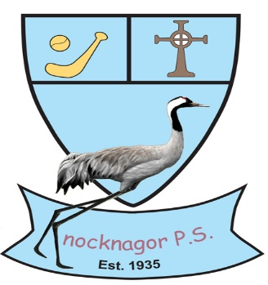
Dear Parent(s),

I welcome you to Knocknagor Primary School. Knocknagor Primary School is a Catholic school, aiming to provide our pupils with a high standard of education, and a wide variety of experiences, in a happy and nurturing environment. At Knocknagor we believe that the quality of your child’s educational experience is greatly enhanced when parents, staff and pupils work closely together. We therefore aim to keep you regularly informed about your child’s progress and welcome your involvement in school life.

I hope that this prospectus will give you a flavour of life at Knocknagor. I would like to invite you to our open day. I would encourage you to visit the school on our open day, but, if the date is not suitable, please feel free to contact me to arrange a visit at another time. Please view our website www.knocknagorps.com or visit the school to find out more about what we can offer your child throughout their primary years.

I hope that you and your child will have a very enjoyable and productive involvement as part of the Knocknagor PS school community.

Yours sincerely,
Briege Baxter
Principal

Staff

- Principal Mrs Briege Baxter
- Year 1/Year 2 Teachers Mrs Terri-Louise Stewart
- Year 3/Year 4/Year 5 Teacher Mrs Briege Baxter/Mrs Emer Kelly
- Year 6/Year 7 Teacher Mr Stephen Mc Gullion

- Classroom Assistants Mrs Vera Brennan
Mrs Mairead Maguire
Mrs Edel Mc Cusker
Miss Mary Kate Mc Quaid
Ms Rebecca Dilworth

- Secretary Mrs Geraldine Quinn

- Building Supervisor Miss Martina Kearns

- Lunchtime Supervisor Mrs Elaine Lennox

Vision
In a celebration of partnership, the staff, governors, parents and pupils will strive to create an educational setting which enables our pupils to grow in wisdom, understanding and mutual respect.

Pupil Aims
- Instilling Christian values of care, respect and social justice.
- All pupils valued and respected unconditionally.
- Acknowledge the worth and dignity of every child.
- Inspire a lifelong love of learning.
- Enabled to take responsibility for their own learning.
- Celebrate all achievements.
- Celebrate diversity.
- Provide diverse range of learning opportunities including an extensive after-schools programme.
- Equip them with the skills necessary to become compassionate and productive members of society.
- Develop a sense of responsibility and citizenship.

School Aims
- Promote inclusion while nurturing individuality.
- Provide effective leadership and governance to drive the vision of the school forward.
- Promote a highly skilled and committed staff with a strong emphasis on professional development to realise the vision.
- Strong parental links.
- Working in partnership with the community.
- All relationships within the school community based on mutual respect.

Our School
Knocknagor Primary School is a Catholic Maintained School, which strives to provide quality education for children between 4 and 11 years. The school is a rural school which opened in 1935, it is situated three miles from Irvinestown and Trillick. Children of all faiths and cultures are welcome in our school.

School Emblem
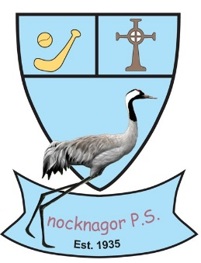
Knocknagor (Cnoc na g-Corr) means “ Hill of the Cranes”. The Celtic Cross symbolises our Catholic faith. The hurl and slither respresent the tradition of hurling in our area. One of the first GAA clubs affiliated to the Tyrone County Board was a football and hurling club named Lisdoo Young Ireland. Lisdoo is in the catchment area of Knocknagor Primary School. The children of Knocknagor designed the school crest in 2006.
School Hours
The school day begins at 9.15am. Children should be in their classes by this time. Children will be supervised from 8.50am – 9.15am each morning by a teacher / supervisor on duty.
There is supervised playtime for all children from 10.45am – 11:00am. The lunch break runs from 12.30pm – 1.20 pm.
P1 & P2 finish at 2.00pm.
P3 – P7 finish at 3.15pm.
Curriculum
In line with the Northern Ireland Curriculum there are three stages from 4-11 years.
- Foundation Stage – P1 & P2.
- Key Stage 1 – P3 & P4.
- Key Stage 2 – P5, P6, & P7.
There are 7 Areas of Learning. This includes:
- Language & Literacy
- Mathematics & Numeracy
- The Arts
- The World Around Us
- Personal Development & Mutual Understanding
- P.E.
- R.E.
Assessment
The Revised Curriculum also means a revised way of assessing your child. Children from P3 – P7 are assessed using Standardised Assessments in May every year. All year groups will also be assessed formally and informally throughout the year.
Our school strives to present children with lively and exciting experiences, which will enable them to work within the Revised Northern Ireland Curriculum, with enthusiasm and according to their abilities. Children’s ability and progression will be reported to parents in November at the Parent/Teacher meetings and in June with a written report. Parents may of course feel free to contact the school throughout the year if they wish to speak to their child’s teacher.
Religious Education
Central to and permeating the life of the school is the spiritual development of its members. There is time set aside each day for class prayer and Religious Education.
Religious Education is taught using the ‘Grow in Love’ programme. Pupils will take part in whole school assemblies, planned and participated in by pupils of particular year groups. These celebrate the main liturgical seasons and feast days. The priests of the parish Canon Mc Kenna and Fr Mc Kenna visit the school regularly and celebrate masses with the school.
If you wish your child to be withdrawn from the Religious Education Programme that our school offers you can speak with the Principal and alternative arrangements can be made.

Sacramental Preparation
Preparation for the Sacraments of Reconciliation and Eucharist will take place in the Religious Education classes in Primary 4. There is a close link between home, school and the parish with the parents of the children.

Preparation for the Sacrament of Confirmation takes place in Primary 7. The parents of the pupils who receive the Sacrament will have the opportunity to be involved through The Service of Light.

Literacy
Our goal is that every child will communicate with confidence, fluency and understanding in talking & listening, reading and writing. Literacy is embedded in all aspects of the curriculum. We endeavour to provide high quality learning situations for all pupils. We have invested heavily in our library book stock so that the children have access to carefully selected materials at their own level. The children’s understanding of the texts is regularly checked through our online programme Accelerated Reading. We use Jolly Phonics in Foundation Stage and The Complete Spelling programme for spelling throughout the school.
Numeracy
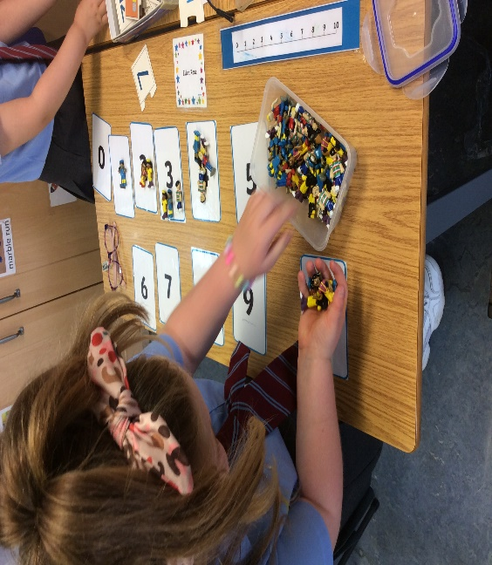
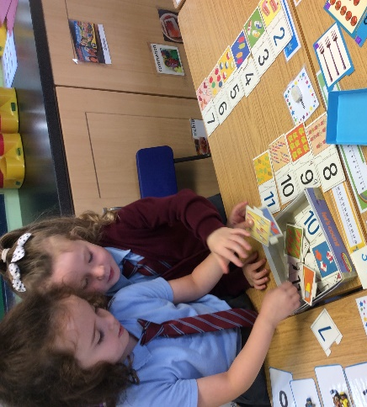
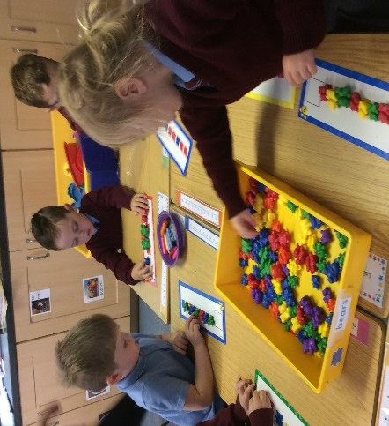
We aim to promote the enjoyment of Numeracy as an essential life skill. We do so by providing pupils with the necessary language, concepts and skills and confidence to be successful in this core area. In the early stages this is gained through a wide range of guided play opportunities and practical activities before moving to a more abstract approach. Emphasis is also placed on the development of metal calculation and problem-solving skills. We use the Izak 9 toolkit to promote problem solving throughout the school.
ICT
We are acutely aware of the technological age in which your children are growing and the ever-increasing emphasis on technological skills. In order that we meet this challenge we have, we continue to invest in technology. Every class throughout the primary school have been equipped with new Promethean interactive whiteboard technology and computer access for pupils. We have individual iPad devices in each of the classes. Through access to a range of programmes ICT also enhances their learning across the curriculum.
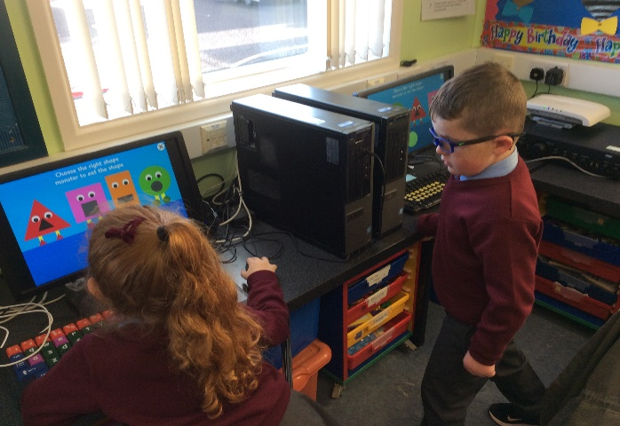
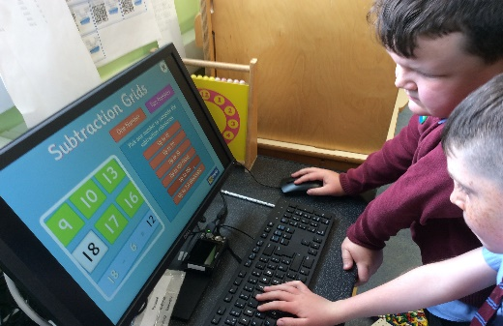

The World Around Us
We believe that it is essential that children grow up with a full appreciation of the world around them and of their responsibilities to maintain it for future generations.
This is done through engaging the pupils in a wide range of experiences which enhance their knowledge in this area. These experiences include trails around the school, growing things within the school grounds, and a range of trips and events in the wider area. Through the use of resources, including the internet, they are also introduced to world-wide issues.
The school also have an Eco-Council who work on a range of issues to improve our environment and to challenge us on issues such as sustainability. We hope that such experiences create an interest in their world within the pupils, which will grow as they become responsible world citizens.
The Arts
Throughout the school we encourage all pupils to identify and develop their creative side. In the early years much of this work is developed through our structured play programme. Pupils throughout the school also participate in a range of assemblies and performances. Our music programme provides whole class tuition in singing and tin-whistle. Pupils have the opportunity to enter solo or form groups to compete in the West Tyrone Feis.
Our Art programme throughout the school provides the children with a range of media within which to express themselves. These include areas such as 3D and modelling work, pencil and sketch work, and computer design.
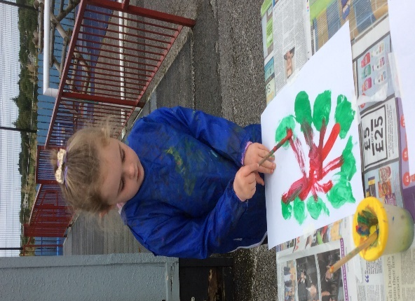
Physical Education
The school offers a full range of Physical Education opportunities for the pupils as part of our curricular provision. This provision is enhanced through the use of sports coaches who visit the school working on football, dance, multi-sports and other skills. The children from Primary 5 to Primary 7 can develop their swimming skills at Omagh Leisure Complex.

Extra-Curricular Activities
Physical education and sporting activity are seen as a very worthwhile and indeed important aspect of school life. Knocknagor offers the children an opportunity for physical activity in PE where games, swimming, athletics, cross country, soccer and dance are offered at different times. The school offers these in the context of living a healthy lifestyle in which physical activity, diet and rest are seen as important ingredients. The school also enters a number of competitive sporting events. We enter events in swimming, soccer, athletics, cross country and Gaelic. In preparation for Gaelic competitions the children often stay after school for training and practices. The school make use of outside coaches and tutors to enhance the range of activities available. Other activities which the school offers at certain times of the year are cycling proficiency, dance and Irish. Participation and enjoyment of sport and activity during or after school, we feel helps to develop the children in many ways and certainly enhances school life for them.
Homework Policy
The purpose of homework is:
- To reinforce learning and understanding of topics covered during the day.
- To encourage parental participation in their children’s learning.
Homework will be given to each child. Homework will be oral, written or both and will relate to work taking place in the classroom.
Types of homework that may be given include:
  - Literacy- practice in language development activities, particularly
reading and spelling.
  - Numeracy- work aimed at improving and reinforcing mathematical
skills.
- Topic work- where pupils carry out inquiry-based activities. On such occasions children may be asked to seek assistance from parents, relations etc. in collecting information and/or relevant resources material.
- Religious Education- learning prayers associated with the Grow In Love programme.

Parents are encouraged to monitor and support their child during homework and ensure that set tasks are completed to a satisfactory standard. It is important to take a real interest in the school and in your child’s schoolwork. Your child will reflect your own attitude towards education.
Parents are strongly encouraged to engage in shared reading and relevant talking and listening activities.
Educational research clearly shows that where a parent spends 10 – 15 minutes each night reading with their child, that child makes significantly greater progress in school than the child who does not receive this support.
Homework should not cause undue anxiety or stress. In the event of this happening, parents should contact the school.
Pastoral Care
It is important to all of us in Knocknagor Primary School to create an atmosphere in which children feel secure, know that they are valued as individuals and are encouraged in their learning, growth and social development in a healthy and safe environment. All members are committed to creating an environment of care and trust where the children are confident and happy and are learning to be considerate of others. Staff promote good standards of behaviour and foster self-discipline, responsibility and independence.
Throughout the year, parents are encouraged to discuss all aspects of their child’s development with the class teacher. Parent teacher meetings are held throughout the year, which give the parent the opportunity to discuss their child’s progress and how they can help him/her. In the event of a child becoming sick during the school day, the guardian/parent will be contacted.
Through programmes such as Relax Kids we ensure that the school maintains a focus on the pupils emotional well-being. Where additional needs arise for a child the school has in place a range of services and outside agencies who can be called upon to assist.
Pastoral Care provision is developed and integrated in each of the Knocknagor Primary School policies. We value student voice through our School and Eco Councils.

School and Eco
Councils

Special Education Provision
Care is taken at all times to match the curricular provision of all children to their particular stage of development and to take account of any particular difficulties or special talents, which they show. This is normally provided by the class teacher or assigned Teacher. Special Needs provision is overseen by the school Special Educational Needs Co-ordinator Mrs Baxter.
It is the policy of the school to identify those children with additional difficulties at as early a stage as possible, to inform parents of the concern and to come to their assistance, as best we can within the resources available.
Additional support is available through individual or small group situations, with programmes tailored to best suit the child’s needs. This may be provided by school staff or through the wide range of WELB support services. Where pupils are receiving additional support, parents will be made aware of the provision and asked to contribute to the programmes through assisting with homework, working on behavioural strategies, attending specialist appointments etc. More information on SEN is available from the Principal.
Inclusive Education
As a school with a very strong Catholic ethos, Knocknagor attempts to live out this ethos through our openness to embrace all who wish to join our school community. We believe this inclusive approach, which embraces pupils of all abilities, all religious beliefs and all cultural backgrounds, enhances the educational experience of all in the school community. We strive to ensure that our educational provision can be modified to address the needs of all the pupils. We engage with a full range of professional and voluntary organisations to ensure that we can maximise the potential learning for all our pupils.
School Discipline
The focus in this school is the development of a positive caring climate, which is based on mutual respect for all people and for the environment in which we live. There is a quiet yet firm insistence on high standards of behaviour at all times and draws strength from a collective responsibility, consistent practice and constant vigilance. There are a range of simple rewards and privileges with due emphasis on merited praise such as Golden Time. Sanctions are also imposed, for example, reprimand, withdrawal of privilege, or loss of personal free time. School and class rules are applied with flexibility, bearing in mind the pupil’s development and the need to be fair.
If poor behaviour is continuing or is detrimental to the child’s or class development in the long term, the Principal will seek the co-operation of the parent in monitoring it and in implementing the on-going programme designed to modify or eliminate the undesirable behaviour. When professional help is required, we will, in consultation with the parents, seek the guidance of the Educational Psychologist or other relevant agencies.

Anti-Bullying
The school takes very seriously any concerns in relation to bullying of pupils at the school. All reported incidents are dealt with by the Principal and in dealing with the incident we hope to ensure that the needs of the victim are addressed and also the needs of the bully. The school has a range of strategies, which we employ to ensure that the welfare of our pupils is promoted. While in the main we attempt to deal with incidents through meeting with and discussing issues with the pupils we also make use of serious discipline sanctions as appropriate. We would encourage all parents to discuss any concerns with their child and to report these to the class teacher or the Principal.
Complaints Policy
From time to time Parents may wish to raise concerns about issues which may be affecting their children’s well-being and happiness. We are a Listening School and our Complaints Policy ensures that Parents can approach the school and air their concerns in the knowledge that they will be given a fair hearing.
Child Protection
Knocknagor has a Child Protection policy in place to ensure that all our children are protected and safe at all times.
Mrs Baxter is the Designated Teacher for Child Protection and Mrs Donnelly is the Deputy Designated teacher for Child Protection. Brendan Mc Elholm is the Designated Governor for Child Protection.
Health and Safety
We recognise our responsibility under current health and safety requirements to endeavour, in as far as is reasonable and practical, to secure the health, safety and welfare of pupils, staff and visitors.
We value our pupil’s well-being and daily encourage healthy attitudes to eating, exercise, rest and hygiene, personally and environmentally. Therefore, we actively encourage healthy breaks and lunches, cleanliness, particularly in sport and games, recycling, conservation of heat and light and respect for ourselves, each other and the environment. We have consistently achieved the Healthy Munch Box Award for the high and consistent standards of healthy packed lunches. We have achieved the Green Flag for Eco Schools.
We are also aware of how lucky we are to live where we do and we promote awareness of how others in the world are less fortunate. Our children, with the help of their parents raise money for various charities. These include, Trocaire, Save the Children and SVDP.
Positive Behaviour
The aim of Knocknagor Primary School is to enable pupils to achieve their physical, intellectual, social and spiritual potential and to improve their self-knowledge and self-esteem within the school environment. In keeping with the tradition and ethos of the school, high standards of personal behaviour are expected from each pupil. This is outlined in our Positive Behaviour Policy.
Rewards and Consequences

Rewards – the positive side of discipline. The emphasis is on the positive approach of encouragement and praise involving incentives and inducements. There are a variety of ways of recognising achievements which the school uses and these include: teacher praise and approval, star charts, privileges, good conduct reports, opportunities for greater responsibilities and Principal’s approval.

Consequences – the aim is to replace the child’s inappropriate behaviour with something more acceptable. To help them reflect on the impact of their actions and consider an alternative response. Poor choices of behaviour will be followed up and there will be some form of restitution. Consequences may include detention at break-time/dinner time, removal of privileges and report to Principal.
School Uniform
We encourage all pupils to wear the correct school uniform.
Girls’ Uniform
Blue blouse, maroon jumper or cardigan, grey trousers or pinafore, and a tie. (A Summer dress, with colours in line with our school uniform, may be worn during Summer/ early Autumn terms).
Boys’ Uniform
Blue shirt, maroon jumper, grey trousers and a tie.
The accompanying tie is maroon with narrow double blue bands. Uniforms can be purchased from J.O’Hanlon, Pound Street, Irvinestown. Each item of the uniform should be clearly labelled with your child’s name.
PE Kit
Children should be provided with suitable clothing for PE. All children should normally have a pair of trainers / plimsoll, shorts and a t-shirt for PE lessons. Children participating in swimming and football coaching will receive a note about what they have to wear.
Holidays
Parents will receive a list of school holidays in September each year. It is important that you try to avoid taking family holidays at times other than when your child is on school holiday.
School Breaks
The school promotes a healthy living programme encouraging exercise and a healthy break. We encourage pupils not to bring crisps or fizzy drinks.
School Meals
School Meals Service provides a mid-day hot dinner and a dessert. Menus are available monthly for viewing in the school. Pupils pay a set price for school meals.
Attendance
All children must attend for 190 days per year, which the law requires. There may from one year to the next, be a variation in the total number of days children can attend as the Department of Education may arrange a number of school development days. On these days’ staff are at work but children will have a holiday. If for any reason your child is absent you should send a note or telephone explaining the absence for our records. If your child has to leave school during school hours or has different arrangements for travel at home time, a note or telephone message is required.
Links with the Local Community
We maintain close links with other primary schools and local secondary schools. This link with our secondary schools ensures that our children’s transition takes place as smoothly as possible. We provide work experience and training opportunities for students from the secondary sector, Universities and Colleges of Education.
During the year we welcome various members of the community and outside agencies into the school – educational psychologist, dentist, nurse, doctor, priests, peripatetic music teacher, outreach teachers, fire service, police service and drugs education support from WELB and of course our parents. We also value the visits our parents and grandparents make when they visit classes to support the children’s learning.

