Knocknagor Primary School

First Aid and Administration Of Medication Policy

Date: September 2022
Review Date: September 2025

Signature of Chair of BOG: ________________________

Signature of School Principal: ______________________

Rationale
At Knocknagor Primary School we aim to do all we can to keep pupils safe and healthy and to protect them from harm. Our Drugs Education programme actively promotes healthy lifestyle choices and makes children aware of the dangers of the misuse of drugs, alcohol, tobacco and solvents. It also teaches children about the safe use of prescribed medication. Knocknagor school recognises that there are pupils who may need to take medication during school hours, for long- or short-term medical needs or in emergency situations. This policy forms part of the school’s overall Drugs Policy. The Principal and Board of Governors of Knocknagor Primary School accept their responsibility under the Health and Safety (First Aid) Regulations (Northern Ireland) 1982 and acknowledge the importance of providing First Aid for employees, children and visitors within the school. ‘First Aid is the initial assistance or treatment given to someone who is injured or suddenly taken ill (The Joint First Aid Manual 8th Edition). Staff administering First Aid should seek to assess the situation, protect themselves and the casualty from further danger, deal with any life-threatening condition and where necessary obtain medical assistance or refer the casualty to hospital as quickly as possible.

Aims/Objectives
The aim of this policy is to make clear the position of Knocknagor school in relation to the administration of prescribed medication to or by children during school hours or whilst on school-related activities. It outlines the roles and responsibilities of teachers, parents and pupils to ensure the safety of our children at all times. It also outlines the procedures for the administration of prescribed medication and the school’s arrangements for providing First Aid.

Statement of First Aid Provision

The school’s arrangements for providing First Aid will:
• Place a duty on the Principal and Board of Governors to approve, implement and review the First Aid policy.
• Place individual duties on all staff.
• Report and record accidents using relevant forms to the Education Authority.
• Record all occasions when First Aid is administered to staff, pupils and visitors.
• Provide equipment and materials to provide First Aid treatment.
• Make arrangements with Education Authority to provide First Aid training to staff, maintain records of training and review annually.
• Establish a procedure for managing accidents in school which require First Aid treatment.
• Provide information to staff on the arrangements for First Aid.
• Undertake a risk assessment of the First Aid requirements of the school and review on a regular basis.
• Use the information from the risk assessment of First Aid to determine the number and level of trained staff and also any additional requirements (e.g., specialised training for children with particular medical needs)
• Notify parent/guardian that first aid treatment was given to the child.

Arrangements for First Aid
The school will provide materials and equipment and facilities to provide First Aid. The location of the First Aid Kit in the School is in the resource room.

A standard First Aid Kit will contain the following items:
- Leaflet giving general advice on First Aid
- Individually wrapped sterile adhesive dressings assorted sizes
- Triangular bandages
- Sterile eye pads
- Safety pins
- Medium wound dressings
- Large and extra-large wound dressings
- 1 pair of disposable gloves

The contents of the Kits will be checked on a regular basis by the First Aid Officer. The School First Aiders are: the Principal, Mrs Donnelly and trained first aiders, Mrs Baxter and Edel Mc Cusker. Before undertaking any off-site activities, the level of first aid provision will be assessed by the Principal / Teacher and at least one First Aid Kit will be taken along.

Accidents involving bumps to a Pupil’s head
The consequence of an injury from an accident involving a bump or blow to a pupil’s head is not always evident immediately and the effects may only become noticeable after a period of time. Where emergency treatment is not required the parent/guardian will be contacted by telephone.

Procedures for the Administration of Prescribed Medication
The staff at Knocknagor school are under no legal obligation to administer prescribed medication of any kind to children in their care during school hours or on school-related activities.
However, we do accept that in a number of cases, a child may present with a medical condition which may or may not be potentially life-threatening, but which does require regular medication. The Principal and staff will treat these cases individually, taking into account the need for specific training and/or the application of emergency procedures that may ultimately save a child’s life. (See Appendix - Form 1, Form 2 and Form 4]

In all other circumstances, the procedures for the administration of prescribed medication will be as follows: For children who do require medication, the school would request that, as far as possible, a parent/guardian/carer/other nominated adult comes to the school to administer that medication.

Safe Storage of Medicines
No child should carry medication on his/her person or in his/her school bag, except in the case of asthma inhalers or other specific medication which needs to be kept with the child at all times, in agreement with staff, parents and child. (See Appendix- Form 3) Other medication kept in school will be stored in the staffroom.

Roles and Responsibilities
Pupils
- Pupils should remember and ensure that they do not carry any medication around the school on their person or in school bags unless an exception has been made, as outlined above.
- No pupil is allowed to consume any medication prescribed for another child.
- If any pupil finds any type of medication on school premises, they must not touch it and must inform a member of staff immediately.
- Where it is appropriate to do so, pupils will always be encouraged to administer their own medication, under staff supervision.
Parents
As far as possible, parents should ensure that all medication is administered outside of school hours. Parents are encouraged to use their own good judgement as to whether their child is well enough to attend school.

- If any short-term medication is to be administered to a child, then his/her parent/guardian/nominated adult must come to the school at the appropriate times during the day, when they will be allowed to administer the medication to that child.
- In the case of asthma inhalers, the child must be able to use the inhaler correctly and class teacher must be informed that the child uses an inhaler.
- In cases of longer term or emergency medication, agreement on the administration of such medication should be reached between staff and parents.
- School staff will not dispose of medicines. Medicines, which are in use and in date, should be collected by the parent at the end of each term. Date expired medicines or those no longer required for treatment will be returned immediately to the parent for transfer to a community pharmacist for safe disposal.

Staff
- School staff will not administer any medication to any child unless in a life-threatening situation as outlined above.
- For each pupil with long term or complex medication needs, the Principal will ensure that a Medication Plan and Protocol is drawn up, in conjunction with the appropriate health professionals.
- Staff will be provided with relevant First Aid Training including training / advice from school nurse.
- Should a child have an accident or fall in yard and needs to be accompanied inside school premises, then a member of staff on duty should accompany that child.
- Final decisions on course of action to be taken in cases of more serious incidents are to be made by the Principal.
- All accidents to be recorded in school’s Accident Record Book, stored above fridge in staffroom.

Administration by Injection
In individual cases where a pupil’s medical needs require medication to be administered by injection, this will be in the context of a specific care plan. All staff will be trained to carry out this care plan. There are exceptions for the administration of certain prescription only medicines by injection in emergencies (in order to save a life). An example of an exception is injection by a fully assembled syringe and needle delivering a set dose of adrenaline by intramuscular injection in the case of anaphylactic shock. Examples are EpiPen® and Anapen®. There are also junior versions for use in children. Any member of school staff may be asked to support pupils with medical conditions (such as anaphylaxis or diabetes) and the school will ensure that the school staff taking on this role, receive sufficient and suitable training and achieve the necessary level of competency before they take on this responsibility.

Accidents
- All accidents will be dealt with in a sensitive manner, the needs of the child will be considered foremost.
- First Aid box will be correctly stocked and placed in a location made known to all staff.
- All accidents will be recorded; accidents will be reported according to EANI accident reporting procedures, as soon as possible after they occur.
- When an accident occurs, staff will assess the situation, and decide whether any action, other than cleaning wound, is deemed necessary.
- If a child needs medical attention, parents will be contacted immediately. If a parent cannot be located, a member of staff will accompany the child to the GP or A & E department and remain with the child until treatment is completed or until a parent/guardian arrives.

Emergencies
In the event of a serious health-related incident, where ambulance assistance is required, school will immediately contact parents; staff will follow procedures set out in the attached Appendix Form 5.

Monitoring and Review
The Safeguarding Team will update this Policy and procedures in the light of any further guidance and legislation as necessary and review it annually. The Principal and Board of Governors will monitor and review this policy regularly.

KNOCKNAGOR PRIMARY SCHOOL- FORM 1- Medication Plan

KNOCKNAGOR PRIMARY SCHOOL- FORM 2- Request for a School to administer medication

KNOCKNAGOR PRIMARY SCHOOL- FORM 3- Request for a Pupil to Carry His/Her Medication
KNOCKNAGOR PRIMARY SCHOOL- FORM 4- Record of Medicines Administered to all Children
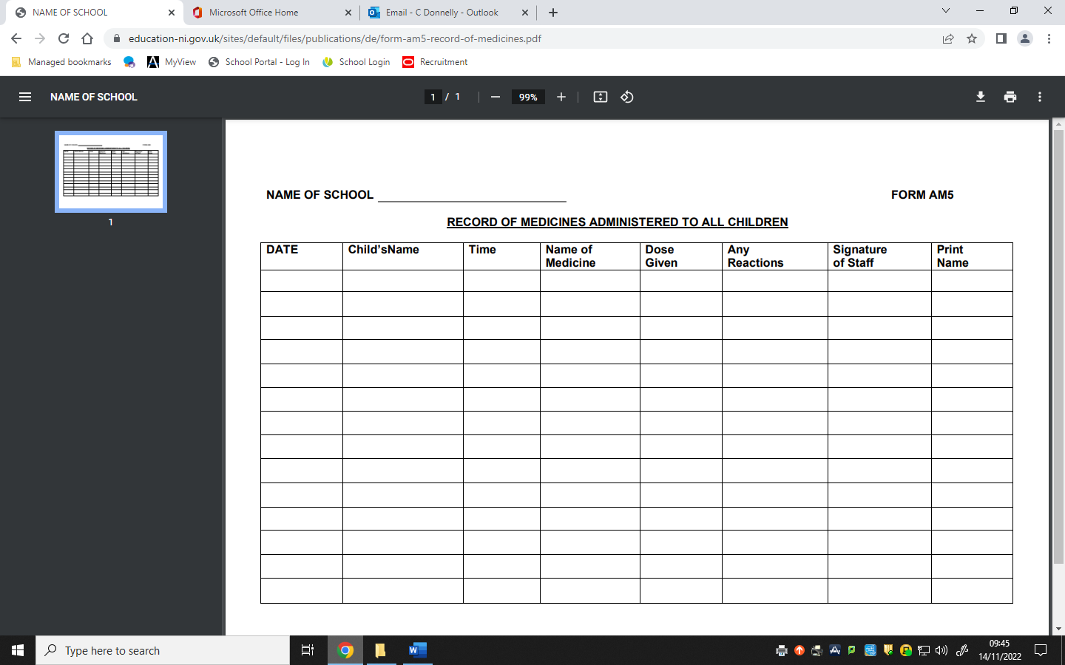

KNOCKNAGOR PRIMARY SCHOOL- FORM 5- Emergency Planning
Request for an Ambulance to: Knocknagor Primary School

Dial 999, ask for ambulance and be ready with the following information.

- School telephone number = 028895 61435

- School name, address and postcode = Knocknagor Primary School,
78 Moorfield Rd., Trillick. BT78 3TX.
- Give exact location in the school [brief description]

[brief description of school location] e.g. =
  - Off Irvinestown to Dromore Road
  - Circa 2 ½ miles from Irvinestown.
  - Take a right at Lisdoo Cross, School situated about ½ mile on the road on right side.

- Give your name =

- Give brief description of pupil’s symptoms.

- Inform Ambulance Control of the best entrance and state that the crew will be met and taken to =

- Ambulance crew will be met at front gate.

