Knocknagor Eco Committee and School Council.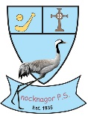

**REDUCE REUSE RECYCLE**

What have we done with the Cash For Clobber and Bun4snack money?

We bought new decorations at Christmas. John and Eoin shopped for a lovely big Santa and 2 polar bears. We have also bought basketball nets and chipper nets for outdoor play.

Thank you for your support.

We have noticed a lot of food waste in school, especially fruit. To prevent this, we are taking part in the Food Waste Challenge.

P5-7 will participate in a workshop on this in March

You can help at home too. More details overleaf.



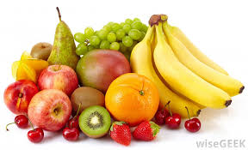

35 school jumpers, 4 coats, a pair of football boots,3 hoodies, several pairs of track suits, trainers, hats and scarves went to Cash for Clobber last week from the Lost Property box.

22 ties were rescued. They have been washed and are ready for use by any child who needs one.

This problem could be solved if everyone had their name on their clothes.

Trocaire is our chosen charity for Lent. Trocaire boxes are available in each classroom. P.3&4 will have a workshop with Rosie from Trocaire on March 13th. The Children have organised a fun ‘Mad March Hair’ day on March 27th. Children may come to school with a wacky hair do and make a 1 donation to Trocaire.